CSA05-DATABASE MANAGEMENT SYSTEMS
LAB OBSERVATION
EXPERIMENT:02
AIM:
To add the constraints like primary key, foreign key, unique key and check using DDL commands.
QUESTION:
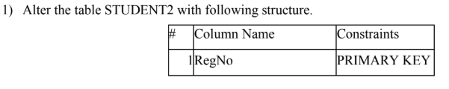
SQL QUERIES:
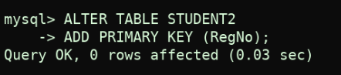
OUTPUT:
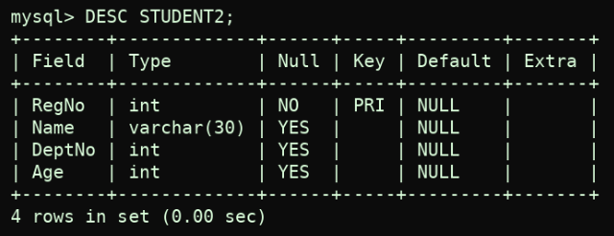
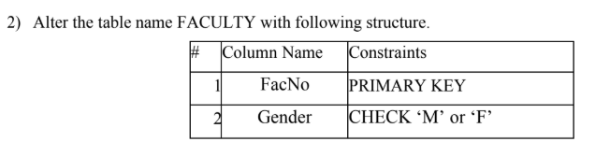
SQL QUERIES:
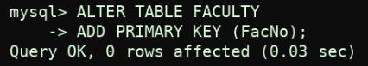
OUTPUT:
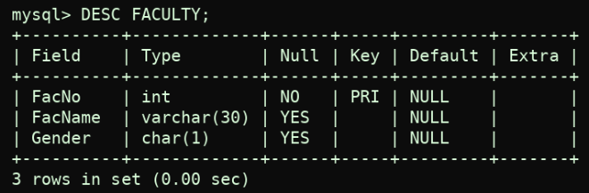
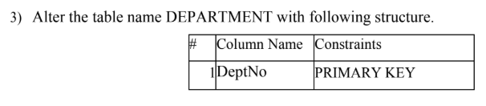
SQL QUERIES:
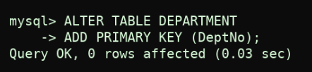
OUTPUT:
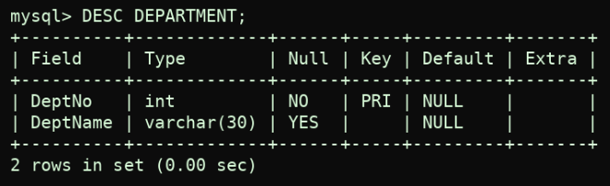
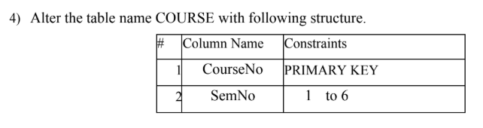
SQL QUERIES:
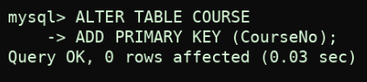
OUTPUT:
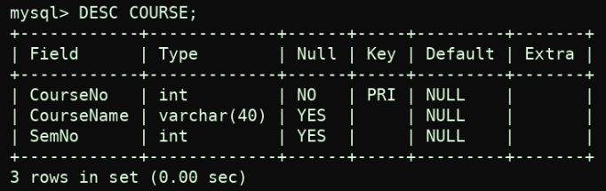
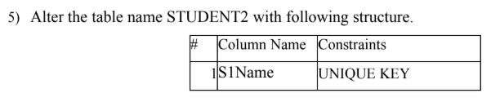
SQL QUERIES:
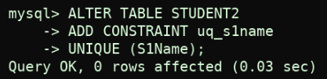
OUTPUT:
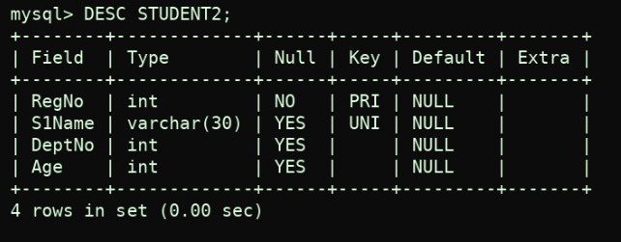
SQL QUERIES:
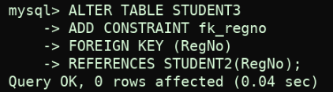
OUTPUT:
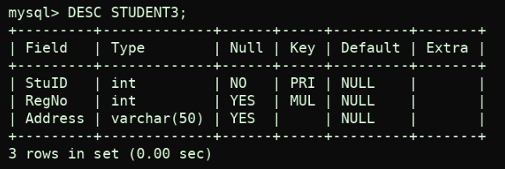

RESULT:
DDL Commands with Primary, Foreign, Unique, Check constraints are updated and verified.

